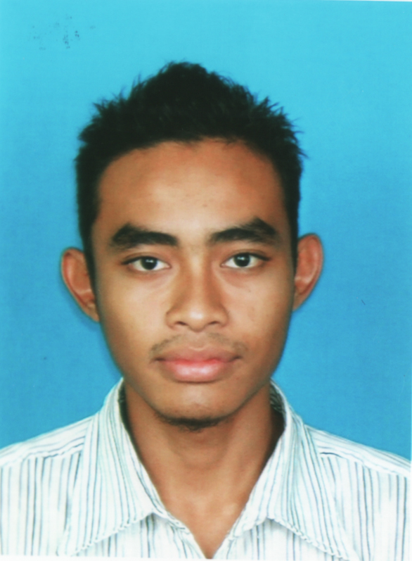
RESUME
MOHAMAD ASBIHANI BIN MOHAMAD NASIR
D-05-32 Apartment Sri Penara,
Bandar Sri Permaisuri,
56000 Cheras,
Kuala Lumpur.
Telephone no: 013-4349201
Email: asbihanin@gmail.com

PERSONAL PARTICULARS
Date of birth: 01 Oct 1988 Place of birth: Kuala Selangor, Selangor
Marital Status: Married Nationality: Malaysian

EDUCATION BACKGROUND
July 2009 – June 2013 Universiti Putra Malaysia Bachelor of Business
Serdang, Selangor Administration
CGPA Score of 3.01

July 2006 - June 2009 Ungku Omar Polytechnic (PUO) Diploma in Banking
Jalan Musa Mahadi 31400 Ipoh CGPA Score of 3.02

2004 – 2005 Sek Agama Men Unwanus Saadah SPM with Distinctions in
Kanchong Darat (SAMUSKD) Mathematics and Science

WORK EXPERIENCE
Jul 2016 – To Date Assistant Warehouse Supervisor (Delivery) at Fiamma Logistic
- To managed operation teams such as OPERATION & OUTBOUND performance within Standard Operation Procedure.
- To managed daily KPI in OPERATION & OUTBOUND.
- To ensure safety, security and good working environment in the department are in good and safe.

Jun 2015 – Jul 2016 Logistic Executive at Maju Home Concept
- Responsible for overall store operation including logistic arrangement, monitoring stock in and out flow movement as well as maintaining proper storage and inventory system management.
- Responsible for the accurate receiving, storage, retrieval and distribution of goods on a timely basis.
- Quality control – ensure that product delivered from suppliers are meet certain quality standards and are safe to delivery.
- Ensure the lorry inspection and road tax are renewed promptly.

Feb 2015 – Jun 2015 Operation Executive at Swift Haulage Sdn Bhd
- Planning and booking truck for loading goods to the ports.
- Ensure deliveries and collections are settled as scheduled.
- Ensure all the operation run clearly and smoothly.

Jun 2014 – Jan 2015 Transport Planner Officer II at TASCO Bhd
- Planning the truck for delivery based on the import and export shipment daily.
- Generate manifest for local movement.
- Planning and arranging lorry driver’s activities to ensure efficiency and productivity.
- Updated daily driver attendance, annual leave and etc.

Sept 2013 – May 2014 Operation Coordinator at Tiongnam Logistic Bhd
- Coordinate closely with internal and external customers to ensure smooth operation.
- Assist superior in day-to-day coordination and management of business operational activities.
- Coordinate and manage project task to ensure project delivery within allocated budget and timelines.
- Do the Truck Mover Record (TMR) for references.

EXTRA – CURRICULAR ACTIVITIES
(UPM) : Laison Officer Assistant in International Children Arts Festival organized by Kementerian Penerangan Komunikasi dan Kebudayaan (2011)
: Participate in program Dinner 13th College as stage manager.
: Participate in hockey, volleyball, and handball intercollege.
Jan – July 2007 : President of the Career Club
(PUO) : Member of the Banking and Finance Club
: Committee Member of Banking and Finance Club

July – Dec 2006 : Committee Member of Banking and Finance Club
(PUO) : Member of the Polytechnic Polybriged

Jan 2004 – Nov 2005 : Member of the “ Persatuan Seni Silat Harimau Jatian Lima”
( SAMUSKD ) : Member of the “Cegah Jenayah” Club

SKILLS / STRENGTHS
- Proficient in Microsoft Work, Power Point, Excel and Adobe Photoshop CS2
- Full clean driving license (B2 and D) and my own vehicle – familiar with Klang, Banting, Kuala Lumpur and Ipoh.
- Can work under pressure and meet tight deadlines.
- Speak fluent Bahasa Malaysia and moderate English.
- Fluent in written Bahasa Malaysia and moderate in English.

REFEREES
The following persons have agreed to provide any additional information regarding my qualification and character
Prof Madya Dr Azmawani Abd Rahman
Deputy Dean
Faculty of Economics and Management
Universiti Putra Malaysia

Email: dr.azmawani@gmail.com
Contact number: 013-350 1037

(Tel: 03-89467773 Fax: 03-89486188)

